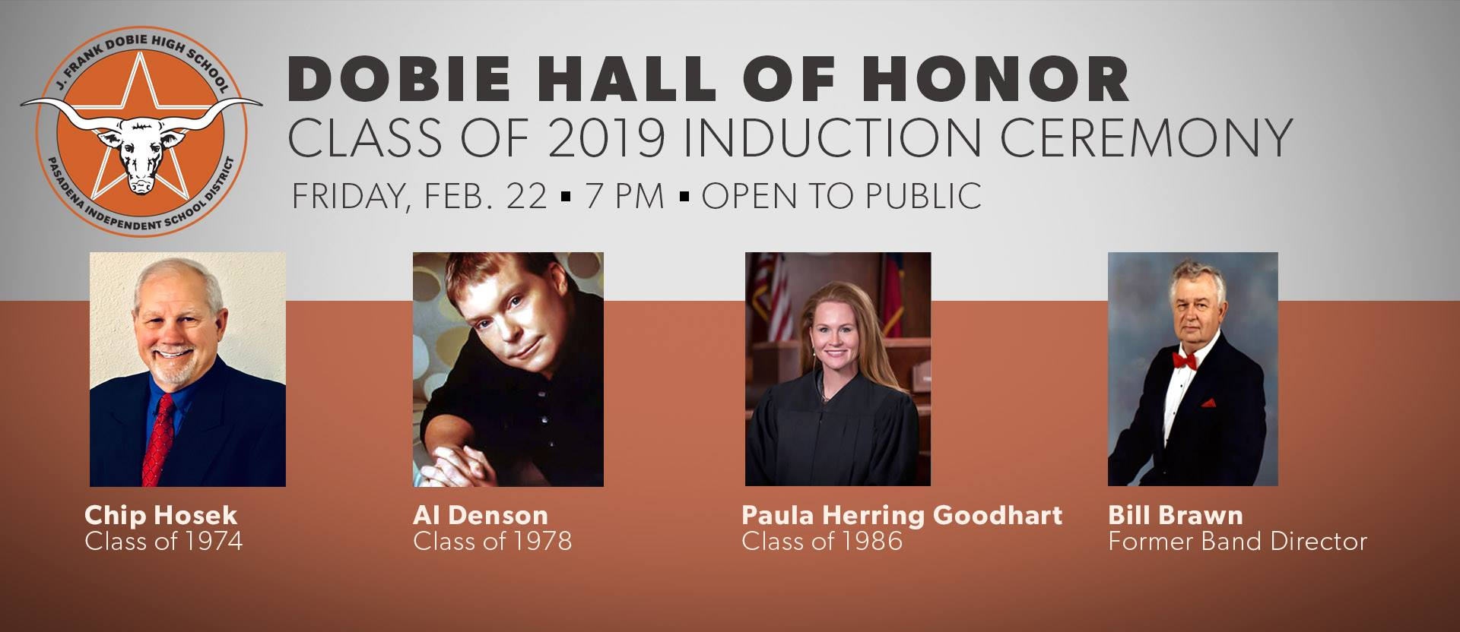
Dobie High School to enshrine four more inductees
Three Dobie High School graduates and one faculty member will be inducted into the Longhorn Hall of Honor, February 22, during the annual induction ceremony. The honorees include Chip Hosek, ’74; Al Denson, ’78; Paula Herring Goodhart, ‘86; and former band director Bill Brawn.
The Dobie High School Hall of Honor recognizes graduates who have made significant contributions to society and serve as role models to Dobie students. This recognition is the highest honor that can be given by Dobie High to one of its alumni or former faculty members.
The induction ceremony will start at 7 p.m., followed by a reception.
The honorees are:
Chipper “Chip” Hosek — Class of 1974
President of Brickfield Builders, Chip Hosek runs a successful longtime masonry business and has been part of many international projects. He served as president of Pearland Little League for several years and regularly donates his time and talents to the community. He has amassed an impressive art collection, An American View: The Hosek Collection of American Art. His art collection has been on loan to several prominent museums and galleries, including The Pearl Fincher Museum of Fine Arts.
Al Denson – Class of 1978
Inducted into the Christian Music Hall of Fame, Al Denson is both a successful Christian recording artist and international humanitarian. As of 2005, he has written 19 songs that have hit the Christian Radio Top 10 list; seven of which have reached the No. 1 spot, including: "Peace Be Still", "Shine Out the Light," "To Forgive", "Be the One", "Take Me to the Cross," "Be," and "Come and Fill This Place." He has been nominated for several awards and won Top Choral Collection Album for Al Denson Youth Chorus Book, Vol. III in 1994 from the Gospel Music Association Dove Awards. He was a featured performer for Billy Graham’s crusades and hosted a weekly television series called “The Al Denson Show,” which aired on TBN. Denson started a program called “The Parent Factor,” a radio show geared toward helping parents and children. He also developed a line of curriculum for students, teaching character education and emphasizing character skills.
Paula Herring Goodhart – Class of 1986
Paula Goodhart graduated with honors from the University of Texas and the University of Houston Law Center. From 1992-2007, she served as an assistant district attorney in the Harris County District Attorney’s Office. She’s tried over 100 jury trials including capital murder, human trafficking, aggravated robbery and sexual assault. Additionally, she has taught criminal law at the Houston Police Department, Harris County Sheriff’s Office, Houston Fire Department and the Pasadena Police Department.
Goodhart served as a judge for Harris Country Criminal Court at Law No. 1. As a judge, she presided over one of five specialty SOBER (Saving Ourselves By Education and Recovery) DWI court dockets. SOBER court is a multi-stakeholder collaborative team effort designed to target high-risk DWI offenders. The mission of SOBER court is to increase public safety while reducing recidivism. She has earned many awards for her efforts, including 2013 MADD Judicial Service Award, 2014 Texas Center for the Judiciary Spotlight on Success Award, 2016 MADD Award, 2017 Texas Center for the Judiciary Faculty Award, 2018 President Award by Houston Bar for Excellence in Service during Harvey and 2018 MADD Policy Setter Award.
Bill Brawn – Former Faculty Member
Bill Brawn, the original band director at Dobie, molded Dobie’s band into a state-recognized powerhouse. Through his innovative leadership, Dobie earned many accolades including UIL Sweepstakes, TMEA Honor Band semifinalist, while also, notably, being the first band in the Greater Houston area, and one of the first in the state to convert to corps-style marching. Dobie, under Brawn’s leadership, became the pioneer school for participation in Drum Corps International -- the first Houston-area school to host a DCI contest, the Lone Star Brass Spectacular, while also encouraging Dobie band members to seek membership. Dobie’s 1981-82 band remains the only one to represent the school at the UIL State Marching Contest, barely missing a spot in the AAAAA finals. After leaving Dobie, he formed the band program at Terry High School in Lamar CISD and also served as band director at East Bernard High School. Bill’s teaching philosophy was to enrich students not only in music, but everyday life skills. Brawn holds several professional memberships in various organizations including Texas Bandmasters, Texas Music Educators and Texas Music Adjudicators Associations. In 2018, Brawn was inducted into the 2018 Texas Bandmasters Hall of Fame.

